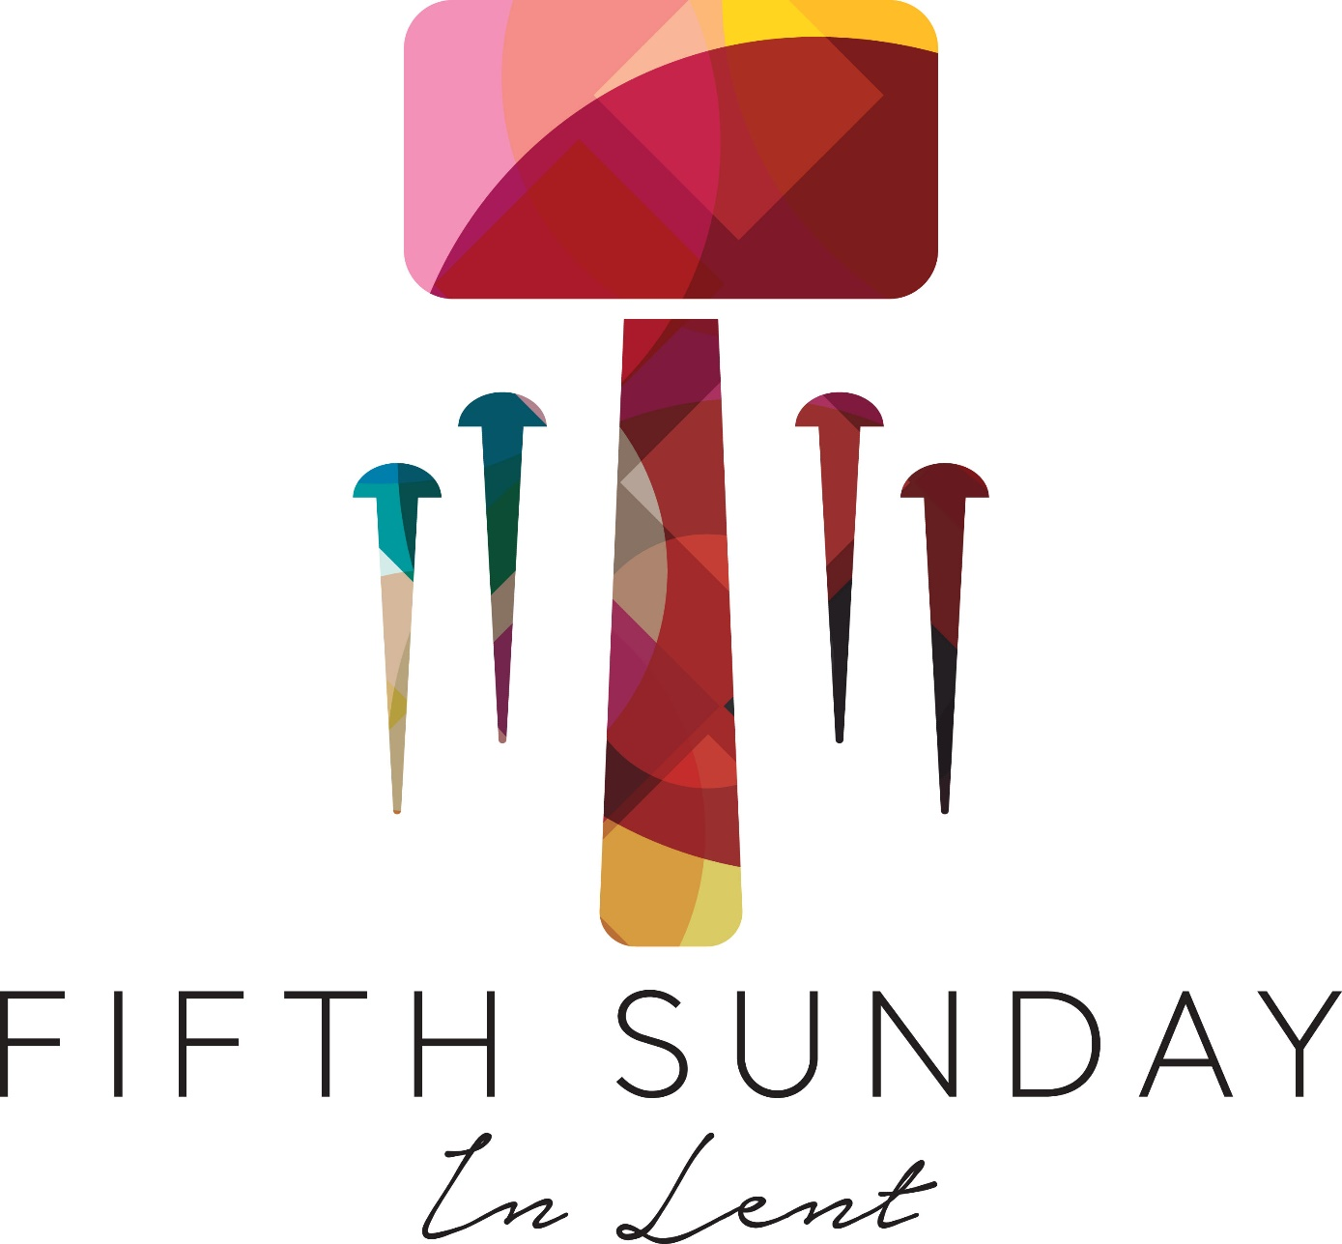

All are invited to worship God here. Our Mission Statement: This church is a family of faith coming from different backgrounds. We are Christ-centered, welcoming to all, and mission-driven.
If you wish to join this congregation, please consult with the pastor after the service or by appointment in the church office or your home.
OPENING Coming to order with song: Hymn #652 “This Is the Day”
This is the day; this is the day that the Lord has made, that the Lord has made.
Let us rejoice, let us rejoice, and be glad in it, and be glad in it.
This is the day that the Lord has made. Let us rejoice and be glad in it.
This is the day; this is the day that the Lord has made.

WELCOME
All are welcome in this sacred space. Come, let us worship the Lord together and share in his peace.
ANNOUNCEMENTS
- Goal 75 for the month of March is laundry detergent
- Feeding Our Neighbors will be serving dinner on Thursday, March 21 at 4:30
- Palm Sunday Service will be on Sunday, March 24th at 10am. Afterwards there will be a potluck luncheon to welcome the Carlos Family. Please sign up in the fellowship hall.
- There will be an Easter Egg hunt for children after worship service on Easter Sunday
- There will not be Sunday School for school age children on Easter Sunday.
CENTERING WORDS
Let us prepare our hearts and minds for worship with these words from Jeremiah chapter 31:
God has written the law of love on your heart. Gaze deeply and find God within.
PRELUDE “Have Mercy on Me O Lord God” J. Krebs
CALL TO WORSHIP [Please stand as you are able for the Call to Worship]
Are you feeling tired and worn out?
Call on the name of the Lord.
Are mistakes from the past weighing you down?
Come to the fount of living water.
Are you the person you wish to be?
Seek God’s help and it shall be granted.
Are you looking for a better path?
Ask Christ to show you the way.
Come! Let us worship.
OPENING PRAYER
Let us pray.
Our souls are troubled, Holy One, until they find their rest in you. When we live in fear of our mortality, help us face the future unafraid. Write the truth of Christ’s words on our hearts: “Unless a grain of wheat falls into the earth and dies, it can only be a single seed. But if it dies, it bears much fruit.” In our living and in our dying, draw us together with all your people. Amen.
PRAISING GOD WITH SONG [Sunday School Children may be dismissed at this time.]
Hymn #11: Stand Up and Bless the Lord”
1. Stand up and bless the Lord, you people of his choice; stand up and bless the Lord your God with heart and soul and voice.
2. O for the living flame, from God’s own altar brought, to touch our lips, our minds inspire, and wing to heaven our thought.
3. God is our strength and song, and his salvation ours; then be his love in Christ proclaimed with all our ransomed powers.
4. Stand up and bless the Lord, the Lord your God adore; stand up and bless his glorious name, both now and evermore.
[Please be seated]
CONFESSION
Together, let us confess our sins before God:
Engraver of the human heart, we long for your law of love to burst forth with every beat of our hearts.
Work within us on this day, that the majesty of your love may shine through us in everything we say and do. Put a new and right spirit within us, O Lord, that we may leave our failings behind and embrace the glory of our salvation, through Christ, our Lord. Amen.
The One who engraves our hearts is faithful, remembering our sins no more. You are loved and accepted, for it is written within by our gracious God.
SCRIPTURE READING John 12:20-33 Pastor William Mitchell
²⁰ Now there were some Greeks among those who went up to worship at the festival. ²¹ They came to Philip, who was from Bethsaida in Galilee, with a request. “Sir,” they said, “we would like to see Jesus.” ²² Philip went to tell Andrew; Andrew and Philip in turn told Jesus. ²³ Jesus replied, “The hour has come for the Son of Man to be glorified. ²⁴ Very truly I tell you, unless a kernel of wheat falls to the ground and dies, it remains only a single seed. But if it dies, it produces many seeds. ²⁵ Anyone who loves their life will lose it, while anyone who hates their life in this world will keep it for eternal life. ²⁶ Whoever serves me must follow me; and where I am, my servant also will be. My Father will honor the one who serves me. ²⁷ “Now my soul is troubled, and what shall I say? ‘Father, save me from this hour’? No, it was for this very reason I came to this hour. ²⁸ Father, glorify your name!” Then a voice came from heaven, “I have glorified it, and will glorify it again.” ²⁹ The crowd that was there and heard it said it had thundered; others said an angel had spoken to him. ³⁰ Jesus said, “This voice was for your benefit, not mine. ³¹ Now is the time for judgment on this world; now the prince of this world will be driven out. ³² And I, when I am lifted up from the earth, will draw all people to myself.” ³³ He said this to show the kind of death he was going to die.
PRAYER FOR ILLUMINATION Pastor William Mitchell
SERMON “It's not about us, it's about the Cross.” Pastor William Mitchell
PRAYER OF THE WORD Pastor William Mitchell
HYMN OF THE WORD [Please stand as you are able and sing]
Hymn #461 “Breathe on Me, Breath of God”
1. Breathe on me, breath of God, fill me with life anew, that I may love whate’er you love, and do what you would do.
2. Breathe on me, breath of God, until my heart is pure, until with you I will one will, to do and to endure.
3. Breathe on me, breath of God, so that your will is mine, until this earthly part of me glows with your fire divine.
4. Breathe on me, breath of God, so shall I never die, but live with you the perfect life of your eternity.
Please be seated
PRAYERS OF THE PEOPLE
Preparation for Prayer
Hymn #421: “Nothing Can Trouble”
Nothing can trouble, nothing can frighten.Those who seek God shall never go wanting.
Nothing can trouble, nothing can frighten. God alone fills us.
Call for Joys and Concerns Pastor William Mitchell
Pastoral Prayer Pastor William Mitchell
Lord’s Prayer [unison]
Our Father, who art in heaven, hallowed be thy name. Thy kingdom come, thy will be done, on earth as it is in heaven. Give us this day our daily bread, and forgive us our debts, as we forgive our debtors; and lead us not into temptation but deliver us from evil. For thine is the kingdom, and the power, and the glory forever. Amen.
OFFERTORY
The One who writes the law of love on our hearts, the One who saves us from the worst parts of ourselves, is here to bless us once more. In giving, we receive; in loving, we find love. Let us show our care for those in need as we offer our tithes and offerings to God. I invite the ushers to come forward to receive our gifts.
[Stand and sing as the offering is brought forward:]
Hymn #34: “Praise God from Whom All Blessings Flow”
Praise God from whom all blessings flow;
Praise him all creatures here below;
Praise him above, ye heavenly host:
Praise Father, Son and Holy Ghost. Amen.
Offertory Prayer [Unison]

With hearts washed clean and with spirits made new, we celebrate the joy of your salvation, O God. May the tithes and offerings we share this day reflect the law of love you have written on our hearts. May these gifts bear the fruit of your Spirit, and may they bless those who need it most. Amen.

CLOSING HYMN [Remain standing as able and celebrate, singing with our children as a church family.]
Hymn “The River is Here”
1. Down the mountain the river flows and it brings refreshing wherever it goes.
Through the valleys and over the fields the river is rushing and the river is here.
Refrain: The river of God sets our feet a-dancing, the river of God fills our hearts with cheer. The river of God fills our mouths with laughter, and we rejoice for the river is here.
2. The river of God is teeming with life and all who touch it can be revived; and those who linger on this river’s shore will come back thirsting for more of the Lord.
Refrain
3. Up to the mountain we love to go to find the presence of the Lord. Along the banks of the river we run, we dance with laughter giving praise to the Son. Refrain
BENEDICTION Pastor William Mitchell
POSTLUDE “Adagio” G. Handel
Please join us in the fellowship hall for fellowship time.

